Cholesky Decomposition in HealthGPS
The HealthGPS codebase implements Cholesky decomposition to generate correlated multivariate normal random variables for risk factor modelling.
- Mathematical Foundation
Cholesky Decomposition Theory
The Cholesky decomposition factorizes a symmetric positive definite matrix A into:
$$A=LL^{T}$$
where $L$ is a lower triangular matrix with positive diagonal elements,
- $L$ is unique if $A$ is positive definite
- $L_{ii}>0$ for all $i$
- $L_{ij}=0$for $i<j$

- Application in HealthGPS
The codebase uses Cholesky decomposition for correlated random sampling in two contexts:
A. Risk Factor Correlation Matrix
- Input: Correlation matrix 𝛴 (symmetric, positive)
- Purpose: Generate correlated residuals for risk factor modelling
B. Policy Covariance Matrix
- Input: Covariance matrix $Σ_{policy}$ (symmetric, positive)
- Purpose: Generate correlated residuals for intervention policy modelling

- Implementation
Step 1: Matrix Loading, assumption that it is all true (which it is), is loaded. Example of matrix used.
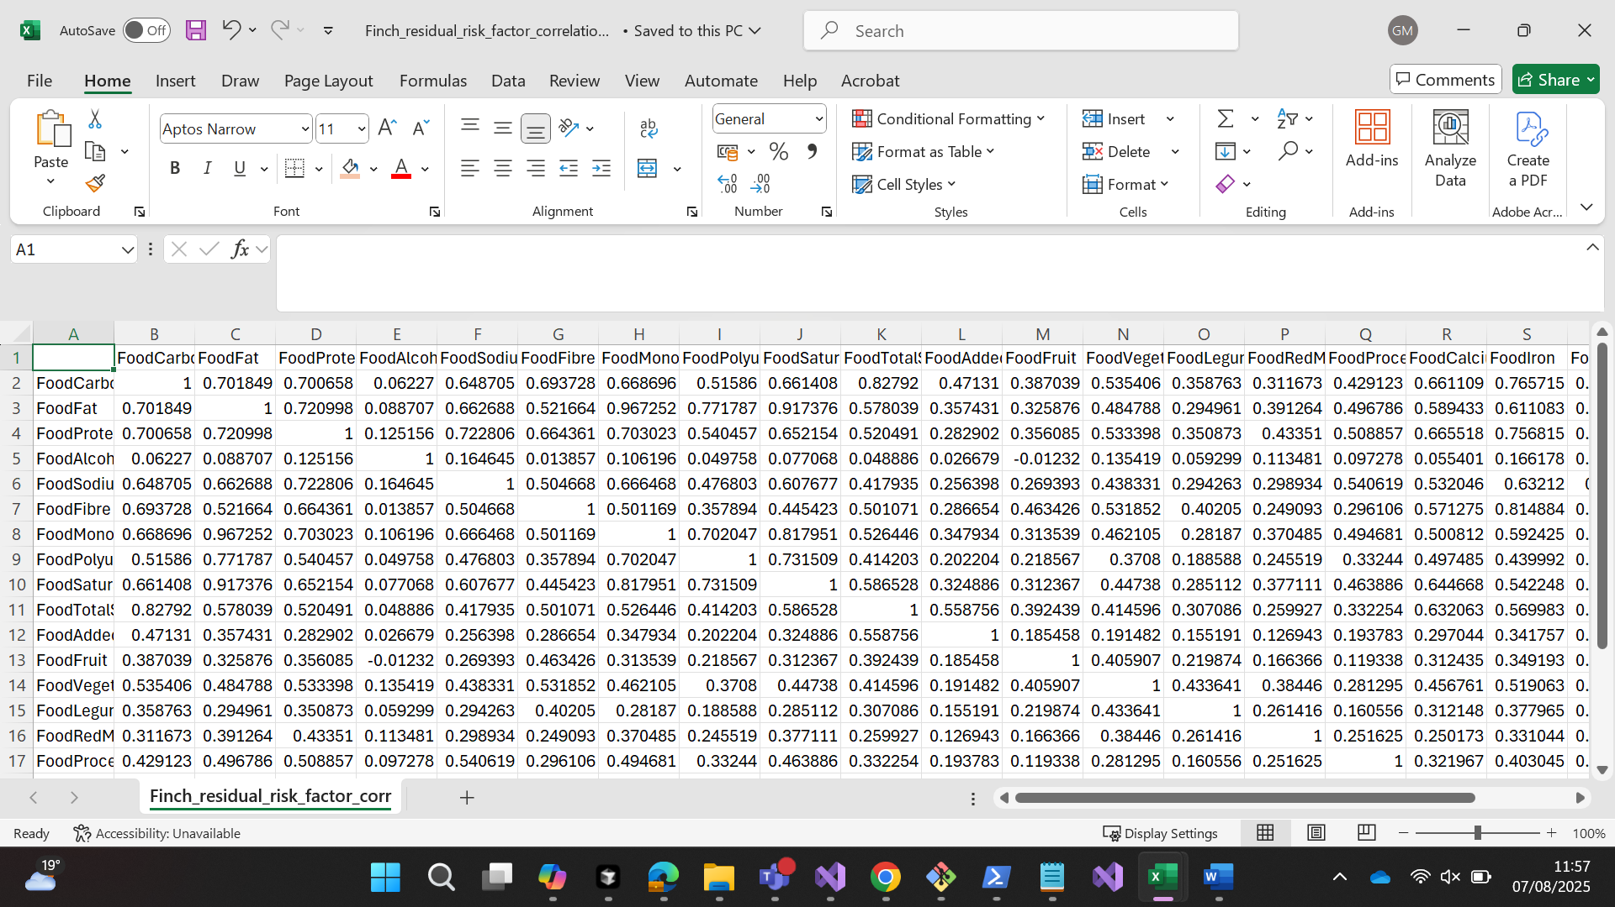
Step 2: Generating Independent Residuals
We start with a vector x of n independent random variables drawn from a standard normal distribution:
x₁, x₂, ..., xₙ ~ N(0, 1)
This means each element of x has a mean of 0 and a standard deviation of 1, and they are uncorrelated.
Step 3: Applying the Cholesky Transformation
We compute the correlated residuals z by multiplying the Cholesky factor L with the independent vector x:
z = L × x
This produces a new vector z whose elements are now correlated according to the original matrix A.

- Simulation Output Interpretation
In the simulation results below, you’ll see two columns highlighted:
- Residual Before Cholesky: These are the independent standard normal values (x).
- Residual After Cholesky: These are the correlated values (z) obtained by multiplying L × x.
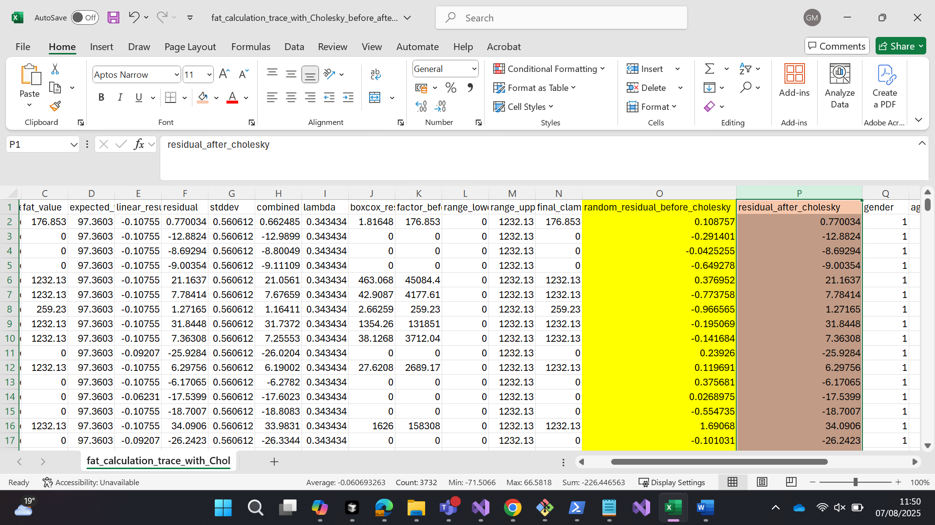
Here you can see that the values of before and after applying Cholesky seems to be very high.

ISSUE: The Cholesky decomposition is producing correlated residuals that are not distributed as they should be. We expect residuals to follow a normal distribution with mean ≈ 0 and standard deviation ≈ 0.56, but we're getting values like 21.16, 31.84, and 49.82, which are 37-89 standard deviations from the mean. This suggests either:
- The correlation matrix has numerical issues
- The Cholesky decomposition is failing to produce properly distributed correlated normals
- There's a numerical stability issue in the decomposition process

For More Information on how the above values are further used-
5. Risk Factor calculation
For each individual, we calculate risk factor values using:
- Linear model: linear_result = intercept + Σ (coefficients × covariates)
Where coeffiencts and covariants are specific to each risk factor (eg- carbohydrate, fat, etc)
- Correlated residuals: Generated using Cholesky decomposition of correlation matrix (steps 1-3 above)
- Combined value: factor = linear_result + residual × stddev
- Final value: Apply Box-Cox transformation and clamp to range
The residuals should be normally distributed with the same standard deviation as the residuals from the external linear regression data (≈0.56), but the Cholesky decomposition is producing extreme outliers.

EXAMPLE OF FAT CALCULATION-
Given Values:
Attribute | Value
Person | Male (gender = 0)
Age | 30
Region | England
Ethnicity | White
Income | 1
Physical Activity | 1.65561
Expected Value | 122.694155649666
Linear Result | -0.107549
Random Residual (Before Cholesky) | 0.108757
Residual (After Cholesky) | 0.770034
StdDev | 0.560612
Lambda (Box-Cox) | 0.343434
Range (Clamp) | [0, 1232.13]

Step 1: Cholesky Transformation
Input Residual (Independent N(0,1)) | 0.108757
Cholesky Matrix Source | Finch_residual_risk_factor_correlation.csv
Output Residual (Correlated) | 0.770034

Step 2: Linear Model Calculation
Parameter | Coefficient | Calculation | Result
Intercept | -0.090842877732224 | — | -0.090842877732224
Gender | -0.017170039347447 × 1 | -0.017170039347447 | -0.017170039347447
Age | 0.000421969617209 × 30 | 0.01265908851627 | 0.01265908851627
Age² | -0.0000090358646826733 × 900 | -0.00813247821441 | -0.00813247821441
Age³ | 0.0 × 27000 | 0 | 0
Region (England) | 0.0 | — | 0
Sector | 0.0 | — | 0
Income | 0.0000190838009472965 × 1 | 0.0000190838009472965 | 0.0000190838009472965
White | 0.0 | — | 0
Asian | 0.0 | — | 0
Black | 0.0 | — | 0
Others | 0.0 | — | 0

Linear Result Calculation:
linear_result = intercept + Σ(coefficients × covariates)
linear_result = -0.090842877732224 + (-0.017170039347447) + 0.01265908851627 + (-0.00813247821441) + 0.0 + 0.0 + 0.0000190838009472965 + 0.0 + 0.0 + 0.0 + 0.0
= -0.090842877732224 - 0.017170039347447 + 0.01265908851627 - 0.00813247821441 + 0.0000190838009472965
= -0.103276306976703
Step 3: Combine Linear Model with Correlated Residual
Calculation | Value
factor_before_boxcox = linear_result + residual_after_cholesky × stddev | -0.103276306976703 + 0.770034 × 0.560612
Calculation | -0.103276306976703 + 0.431834
Result | 0.328558

Step 4: Boxcox Transformations
boxcox_result = inverse_box_cox(factor_before_boxcox, lambda)
= inverse_box_cox(0.328558, 0.343434)
Using the formula: inverse_box_cox
boxcox_result = ((0.343434 × 0.328558) + 1)^(1/0.343434)
= (0.112823 + 1)^(1/0.343434)
= (1.112823)^(2.912)
= 1.81648

Step 5: Apply expected value (Factors mean adjustments)
factor_before_clamp = expected_value × boxcox_result
= 122.694155649666 × 1.81648
= 222.853
Step 6: Clamp to range
final_clamped_factor = clamp(factor_before_clamp, 0, 1232.13)
= clamp(222.853, 0, 1232.13)
= 222.853

